Aimal Sadia Khan

DATA MODELLING SCENARIO

Table of Contents

PART 1 3
1.1. Spreadsheet 3
PART 2 6
2.1. RELATIONAL SCHEMAS 6
Coffee shop table 6
Categories table: 6
Customers table: 6
Sales_Transactions table: 6
Relationships 7
Normalization 7
1. CoffeeShops 7
2. Categories 7
3. Customers 8
4. SalesTransactions 8
2.2. CONCEPTUAL ERD 9
2.3. LOGICAL ERD 10
2.4. PHYSICAL ERD 11

PART 1
PART 1 (Spreadsheet).xlsx

1.1. Spreadsheet
- Column C (Price): Prices were manually entered.
- Column D (Quantity): Quantity of each item sold per transaction was manually.
entered.
- Column E (Total Sales): = Costs were manually entered.
- Column F–I (Statistical Data): Used SUM, MIN, MAX, and AVERAGE functions for different ranges.
- Total quantity sold: SUM (B11:B47)
- Min sales: MIN (G12:G47)
- Max sales: MAX (G12:G47)
- Average sales: AVERAGE (G12:G47)
- Red for loss (negative cash flow)
- Yellow for profit up to £1,000
- Green for profit over £1,000
Line Graph: Sales, Monthly Cash Flow, and Profit/Loss (3-Year Period)
- The blue line shows initial income peaking sharply early in the period, representing a strong revenue month.
- The x-axis labels reflect monetary values (£) which likely represent monthly revenue amounts, although they would be more appropriately labeled with months or time periods (e.g., Jan 2023, Feb 2023).
- The orange line indicates the cumulative profit or loss over time, showing a consistent downward trend into negative values. This suggests that while income may have spiked early on, expenses outpaced earnings, leading to a long-term deficit.
- The graph helps visualize how cash flow fluctuations impact overall profitability across the 3-year timeline.
Bar Chart: Monthly Sales Overview
- The chart shows high sales activity in the initial months, particularly around month 5 where sales peaked at over £120,000.
- Sales gradually declined in subsequent months, with very low or no sales activity past month 9, suggesting a sharp drop-off or operational halt.
- The y-axis indicates sales revenue in pounds (£), showing the scale of sales performance.
- The x-axis currently uses numeric intervals (1, 3, 5, etc.) which should ideally be replaced with actual month names (e.g., Jan, Feb) for clearer context.

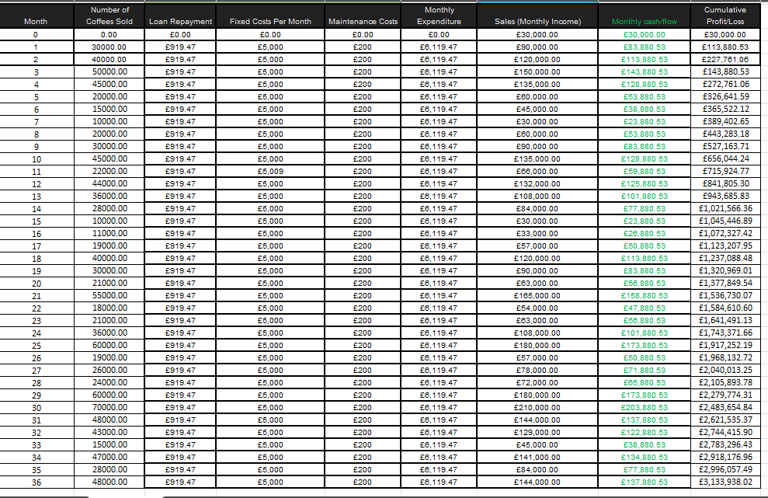

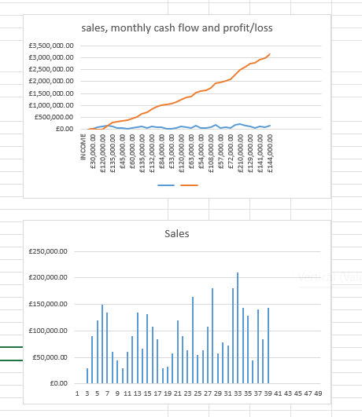
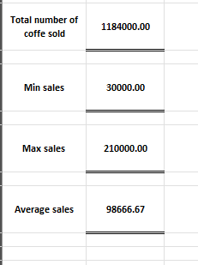

PART 2

2.1. RELATIONAL SCHEMAS

Coffee shop table
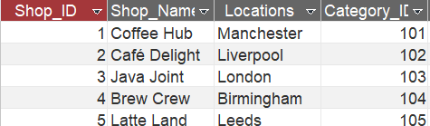

Categories table:

Customers table:
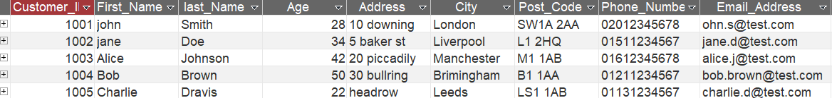

Sales_Transactions table:
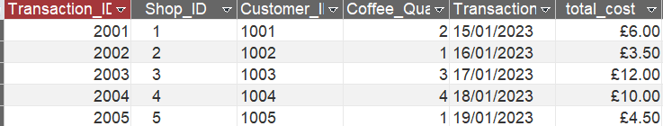

Categories Query table

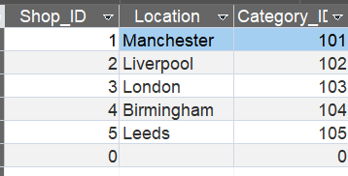

Coffee_Shop Query table

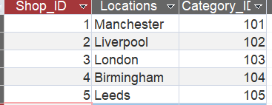

Relationships

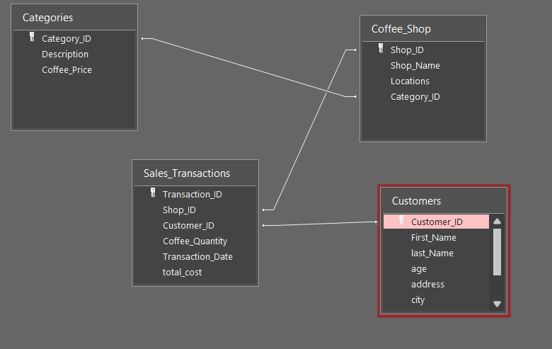

Normalization

1. CoffeeShops
- ShopID (PK)
- ShopName
- Location • CategoryID (FK)
3NF:
- All fields depend only on ShopID, the primary key.
- CategoryID is a foreign key but not a transitive dependency because its details are stored in the Categories table.

2. Categories
- CategoryID (PK)
- Description • CoffeePrice
3NF:
- Description and CoffeePrice directly depend on the primary key CategoryID, not on each other.
- No transitive dependencies.

3. Customers
- CustomerID (PK)
- CustomerName
- Age
- Address
- PhoneNumber
- Email
3NF:
- All attributes are fully functionally dependent on CustomerID.
- No transitive dependencies (e.g., phone number doesn’t depend on address or email).

4. SalesTransactions
- TransactionID (PK)
- ShopID (FK)
- CustomerID (FK)
- Quantity
- TransactionDate
- TotalCost
3NF:
- All non-key fields depend only on TransactionID.
- No transitive dependencies assuming TotalCost is retained with justification (for record-keeping or historical pricing).

- TotalCost is stored for tracking historical prices even if price changes later — so it's okay in 3NF with justification.
- All IDs are used properly as foreign keys and link to their respective parent tables.
- No derived fields violate the 3NF unless intentionally kept.

2.2. CONCEPTUAL ERD
https://drive.google.com/file/d/1ENregjoorPbUXEDvT48qWuK1Gxt67VZg/view?usp=sharing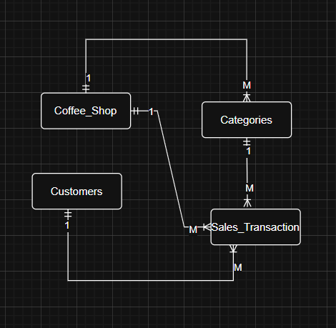

2.3. LOGICAL ERD
https://drive.google.com/file/d/1Kp1Y3kFvRwCqFqiNyRj2GKVJC_NqG9S1/view?usp=sharing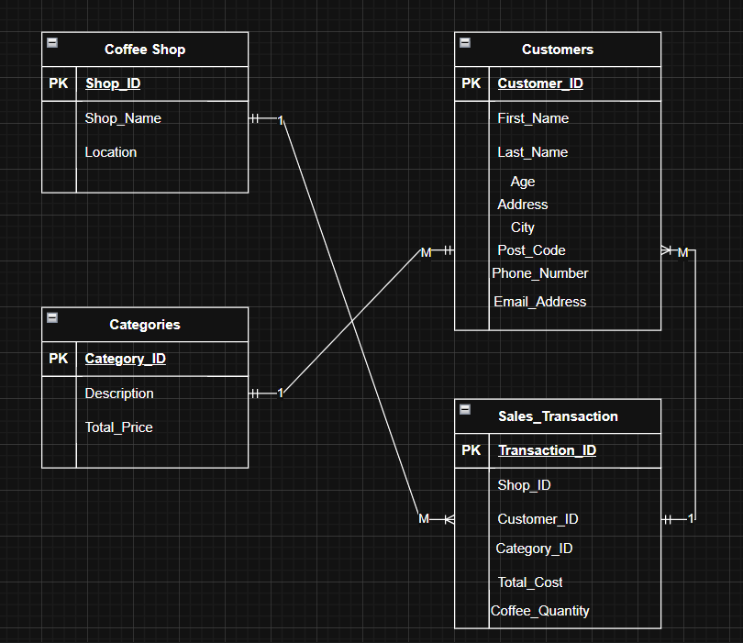

2.4. PHYSICAL ERD
https://drive.google.com/file/d/1cIljhDWB5RMWBMwSAZM3NEYEijeX6nh2/view?usp=sharing

